Personal Details  Date of Birth: Sep 22nd, 1992.  Nationality: Israeli + EU Passport  Marital Status: Single.  Israeli ID: 307867812.  Place of Birth: Haifa, Israel. | 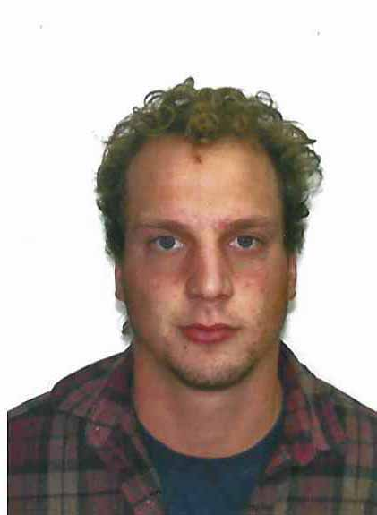

Contact information

Address in Israel: Alon Hagalil, Israel, 1792000.
Mobile: +972-50-2229314.

Email: sadenimrod@gmail.com

Education

2011 – Graduated high school, Nahalal Agri School.

Courses:

2009 – Youth Leader Course – The Moshavim Youth Movement.

2013 – STCW, The Authority for Marine Training and Education, Akko.

2019 – SCUBA – PADI Divemaster– Dahab Egypt.

2020 – Rope Access – P.S.K Group – Rope access.

Certificates:

- PADI Divemaster.

Related Employment and Work Experience
Period: Dec 21 – Today.
Employer: Millennium Farms, Jordan.
Position: Operation and maintenance manager in greenhouse.

Period: Feb 2020 – Sep 21.
Employer: Self employed.
Position: Rope Access Worker.
Rope Access duties mainly building maintenance and monitoring.

Period: June 19 – Sept 19.
Employer: Palso (Personal aluminum Solutions).
Position: Construction Team leader.
Managing construction teams at Aluminium wall covering and decks projects.

Period: Feb 19 – May 19.
Employer: Dagan Agricultural Automation.
Position: Eco system technician at Cannabis greenhouse construction.
Installation of shaded curtains and cooling pads.

Period: Feb 2017 – Feb 2018.
Employer: Kibbutz Gan Shmuel, Dairy Farm.
Position: Deputy Manager of the Cowshed.
Responsible for the operating of the cowshed including, milking, feeding, health care and equipment maintenance.

Period: July 2016 – Jan 2017.
Employer: Piltsevich Farm, Moshav Hayogev.
Position: Agri Shaker (for almond and olives picking) operator and team leader.
Responsible for the operation and maintenance of 3 sets of heavy equipment, and team of 10 operators and labours.

Period: Aug 2011 – Aug 2012.
Employer: Kibbutz Kerem Shalom, Field Crops (“GADASH”).
Position: Agriculture Equipment Operator (Heavy Tractors and Combines).

Military Service

Period: Jan 2013 – Jan 2016.
Position: Serve on Israeli Navy Motor Vessel as Mechanical Technician.

2013 – 2014 – Certified Mechanical Technician – Responsible for the Engine Department operation including commanding on 10 soldiers.

2014 – 2016 – Duty Officer – Responsible for the operation of the vessel during absent of commander and officers.

Volunteering

Pre-Army Service Year – Kibbutz Kerem Shalom – Mainly Agriculture works and leading of the Kibbutz social life.

Other Skills and Remarks

- Self-Motivated.
- High technical skills.
- Fast self-Learning.
- Managing Experience and abilities.
- Highly sociable.

Languages

- Hebrew – Native Language.
- English – Speaking – Very Good, Writing – Good.

